Retalyy AI Document Intake System: System Design
Oct 17, 2026 · @rafi

Overview and goals
The system automates the first step of an accounting engagement: receiving client documents, checking them against what the client should have sent, and chasing what is missing. Accountants only see complete, organized cases and the exceptions that need judgment.
Problem. Intake takes roughly 8–28 minutes of staff time per straightforward submission (illustrative estimate), and clients can take days to answer a missing-document request. The work is repetitive, rule-driven, and sits before all the higher-value accounting work.
V1 scope
- Receive documents from email and a client portal (accounting-software and bank-feed integrations come later).
- Identify the client, accounting period, and document type.
- Check readability and extract basic metadata.
- Compare submissions with a client-specific expected-document checklist.
- Draft missing-document follow-ups for accountant approval.
- Flag duplicates and anomalies, then create a case and route it to the right accountant.
Non-goals for v1
- Transaction classification, reconciliation, or any accounting judgment.
- Tax-law interpretation or final financial sign-off.
- Fully autonomous client communication (every message is approved by a human at first).
Success metrics
Metric | Target (to be validated)
Staff time per routine submission | Under 5 minutes of review, down from 8–28
Document type classification accuracy | 95%+ on a held-out test set
Client and period identification accuracy | 98%+, with the rest sent to a human
False "missing document" requests sent to clients | Under 2%
Time from submission to case ready for an accountant | Under 15 minutes for routine cases

Architecture
Every channel feeds one ingestion gateway, and a staged pipeline processes each submission before it reaches a person.
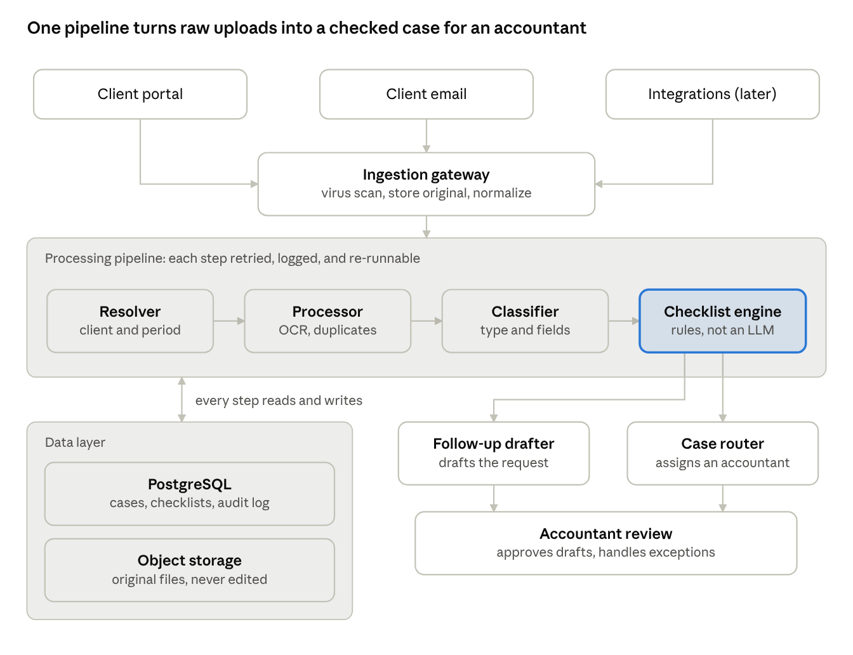
architecture · 3 channels, 1 pipeline, 2 outputs
The checklist engine (highlighted) is plain rules, so every "missing" flag can be explained. The AI reads and labels documents; it does not decide what is missing. Accountants only see the output: approved follow-ups and a routed case.

Components
Seven services handle a submission in order; each one writes its result to the case record, so any step can be re-run or overridden by a human.
# | Component | Job | Key design choice
1 | Ingestion gateway | Accepts files from the client portal, a per-client email address, and (later) accounting-software and bank-feed integrations. | Every channel produces the same normalized "submission" event; files are virus-scanned and stored untouched before anything else runs.
2 | Client and period resolver | Works out which client and which accounting period a submission belongs to. | Uses sender address, portal login, and file contents, in that order of trust. Low confidence goes to a human triage queue.
3 | Document processor | Checks that files open, are readable, and are not duplicates; runs OCR on scans and photos. | Duplicate detection uses file hashes plus matching on account, date range, and totals.
4 | Classifier and extractor | Labels each document (invoice, bank statement, receipt, payroll report, tax form) and extracts metadata such as account, statement period, and totals. | An LLM with a document-vision model, constrained to a fixed schema; every field carries a confidence score.
5 | Checklist engine | Compares extracted documents with the client's expected-document checklist for that period. | Deterministic rules, not an LLM, so "missing" is explainable and auditable.
6 | Follow-up drafter | Writes a missing-document request that names the exact items and the deadline. | Drafts go to an accountant for approval in v1; auto-send can be enabled per client later.
7 | Case router | Creates the case, attaches records, sets the due date, and assigns an accountant. | Assignment by client ownership first, then workload; complex or flagged cases go to a senior accountant or manager.
The checklist is the critical piece. A document is only "missing" if the client's checklist says it should exist. Each checklist stores the client's connected bank and card accounts, recurring documents, and period type (monthly, quarterly, annual), plus legitimate exceptions such as a dormant account with no statement this month. Accountants maintain it, and the system proposes edits when it sees a new account or a stopped one.

Data model
A relational database (PostgreSQL) holds the case state; original files live in object storage and are never modified. Every AI output is stored beside the human correction, if any, which also builds the training and evaluation set.
Entity | Main fields | Notes
Client | id, name, service types, owning accountant, contact addresses | One client can have several service types: bookkeeping, tax, payroll.
Client account | client, type (bank, card, payroll, invoicing), identifier suffix, status | Drives which statements the checklist expects.
Checklist template | client, service type, period type, required items, exceptions | Versioned; changes are logged.
Period | client, start, end, deadline, status | Status runs open, in review, complete.
Submission | client, period, channel, received at, sender, status | One upload event; may contain many documents.
Document | submission, file location, hash, type, extracted fields, confidence scores, review status | Original file is immutable.
Finding | period, kind (missing, duplicate, unreadable, anomaly), related document, resolution | What the checklist engine and processor raise.
Message | client, direction, draft text, approver, sent at | Follow-ups and client replies, threaded to the period.
Task | period, assignee, due date, state | The case handed to an accountant.
Audit event | actor (user or system component), action, before and after, timestamp | Append-only; covers every state change.

AI design and human review
The model reads and labels documents; code decides what is missing. That split keeps the highest-stakes judgment ("ask the client for more") explainable.
Confidence-based routing
Confidence | What happens
High | The result is accepted and the case moves on automatically.
Medium | The result is accepted but shown to the accountant as "please verify" on the case.
Low | The document goes to a triage queue; nothing downstream runs until a person labels it.
Thresholds start conservative and are tuned per field from real correction data. Client identification and period identification get the strictest thresholds, because a document filed under the wrong client is the worst failure.
Rules the system never breaks
- It never marks a document "missing" without a checklist item that requires it.
- It never sends a client message without approval until a client is explicitly switched to auto-send.
- It never changes a checklist on its own; it only proposes changes.
- Every flag carries a plain-language reason an accountant can verify in seconds.
Evaluation
- Before launch, build a labeled set from real past submissions (anonymized) covering clean, messy, scanned, and incomplete cases.
- Track classification accuracy, extraction accuracy per field, false-missing rate, and accountant override rate weekly.
- Every accountant correction becomes a new test case; releases must not regress on the existing set.

Security, privacy, and audit
Client financial records and tax documents are among the most sensitive data a firm holds, so isolation and traceability come before convenience.
- Tenant isolation. Each accounting firm's data is logically separated, with a firm and client identifier checked on every query, not just at login.
- Encryption. TLS in transit; encryption at rest for the database and object storage, with per-firm keys where the firm requires it.
- Access control. Role-based access: administrators see intake queues, accountants see only their assigned clients, managers see escalations.
- AI data handling. Use a model provider under a contract that forbids training on client data; redact or avoid sending identifiers such as full account numbers when the task does not need them.
- Upload safety. Malware scanning, file-type allow-lists, and size limits on every channel; email attachments are treated as untrusted.
- Audit trail. Every read of a client document, every AI decision, and every human override is logged, append-only, and exportable for a firm's own review.
- Retention. Retention and deletion periods are configurable per firm to match local record-keeping rules.
Open compliance question: which jurisdictions the first customers operate in decides the exact data-residency and retention requirements (for example GDPR, or local tax-record rules). Confirm this before choosing hosting regions.

Tech stack, deployment, and reliability
The stack is a suggested starting point; swap pieces to match the team's skills.
Layer | Suggested choice | Why
Client portal and staff app | React with TypeScript | Common skills, fast to build upload and review screens.
API and services | Python (FastAPI) | Same language as the document and AI tooling.
Workflow orchestration | Queue-based pipeline with a workflow engine such as Temporal | Retries, timeouts, and human-approval waits are built in.
Database | PostgreSQL | Relational model fits cases, checklists, and audit.
File storage | S3-compatible object storage | Immutable originals, versioning, lifecycle rules.
Email intake | Inbound email service that posts to a webhook | One address per client, no mailbox polling.
OCR and document AI | Managed OCR plus a vision-capable LLM | OCR for scans, LLM for classification and extraction.
Auth | OIDC single sign-on for staff, magic link or password plus MFA for clients | Clients rarely have firm accounts.
Observability | Structured logs, metrics, and tracing per submission | Every case can be replayed end to end.
Reliability. Each pipeline step is idempotent and retried with backoff, so a crash or a model timeout never loses a submission. A submission that fails three times lands in a visible dead-letter queue for staff rather than disappearing. Intake volume is bursty around month-end and filing deadlines, so workers scale on queue depth, and files are processed in parallel.

Rollout, risks, and open questions
Roll out in four phases, each gated by measured results rather than a date.
- Shadow mode. The system processes real submissions but takes no action; staff compare its output with what they did by hand. Gate: classification and client identification meet the targets above.
- Assisted intake. Accountants see the case, findings, and drafted follow-ups, and approve each one. Gate: false-missing rate stays under 2% and staff report time saved.
- Selective auto-send. Follow-ups go out automatically for clients with stable checklists and a good track record.
- Integrations. Add accounting-software and bank-feed connections, which reduce the document-chasing work itself.
Main risks
Risk | Mitigation
A document is filed under the wrong client or period | Strict thresholds, human triage for low confidence, audit trail.
Clients get wrongly told something is missing | Checklist-only rule, approval before sending, tracked false-missing rate.
Checklists go stale as clients change | The system proposes updates when accounts appear or stop; accountants own the checklist.
Staff do not trust the output | Shadow mode first, plain-language reasons on every flag, easy overrides.
Poor scans and photos | Image-quality check at upload with an immediate retry request to the client.
Open questions
- Which firm size and client type come first: small firms with one accountant, or larger firms with a central intake team?
- Which channels matter most on day one: portal, email, or both?
- Which jurisdictions and document types (tax forms, payroll) are in scope for the first release?
- Does Retalyy build the client portal, or integrate with the firm's existing one?

